**FINAL ASSIGNMENT**

**Q: 01:**

Find the Jacobian of the Transformation

$$x= u^{2}-v^{2}$$

$$y= u^{2}+v^{2}$$

**Q: 02:**

The Y bus matrix of a 100-bus interconnected system is 90% sparse. Then find the number

of non-zero in the Y bus matrix?

**Q: 03:**

A three-phase transmission system, a fault occurs on R-phase (or single line to Ground Fault) as shown in Figure below. Calculate the Fault current and draw the sequence network.

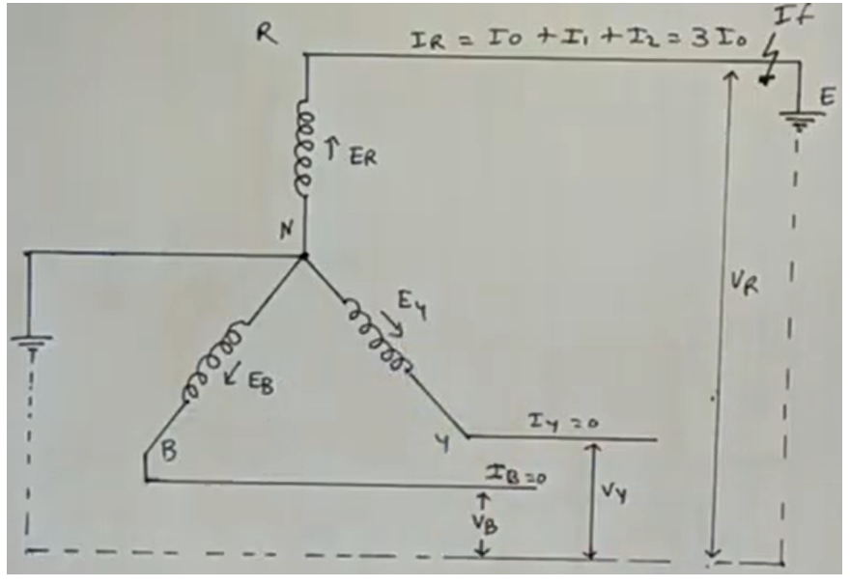

**Q: 04:**

One conductor of a three-phase line is open. The current flowing to the Δ-connected load through line a is 10A. With the current in line a as a reference and assuming that line c is open, find the symmetrical components of the line currents.

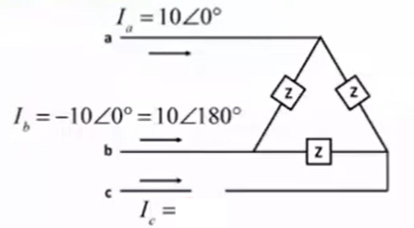

**Q: 05:**

A Y-connected load has balanced currents with abc sequence given by

$$I_{P}=\left[\begin{matrix}I_{a} \\ I_{b} \\ I_{c}\end{matrix}\right]=\left[\begin{matrix}10<0^{0} \\ 10<+120^{0} \\ 10<-120^{0}\end{matrix}\right] A$$

Calculate the sequence currents ($I_{0}$, $I_{1}$, $I_{2}$)

**Q: 06:**

Derive the equation of sequence impedances of Y-connected loads

$$Z^{012}=\left[\begin{matrix}Z_{s}+3Z_{n} & 0 & 0 \\ 0 & Z_{s} & 0 \\ 0 & 0 & Z_{s}\end{matrix}\right]$$

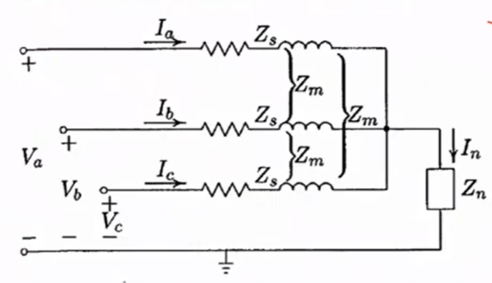

**Q: 07:** Write Shor Note

1. Define load bus, Generator Bus and Slack Bus and draw its basic diagram?
2. State and explain the sparsity in power system analysis?
3. Difference between Symmetrical and Unsymmetrical Components
4. Positive, negative and zero sequence components and Proof 1 + a + 2 = 0
5. Derive the Complex power $S_{(3∅)}= 3 {V_{a}^{0}I}_{a}^{0*}+ 3 {V_{a}^{1}I}_{a}^{1*}+3 {V_{a}^{2}I}_{a}^{2*}$
6. Define Sequence Impedance
7. Fault and its different types of Faults in overhead Transmission System
8. Write the basic three steps of Cholesky’s Method
9. Give the simple example of Jacobi’s Iteration Method
10. Write the basic steps of Gauss Jordan Method

***THE END***